|  |  |
| --- | --- |
| Project Case |  |
| COMP6051 | COMP6051016 | COMP6051049  Web Programming |
| **Computer Science** | **E232-COMP6051-AW02-00** |
| ***Valid on*** *Even Semester Year 2022/2023* | **Revision 00** |

1. Kelompok tidak diperkenankan untuk:

*Members of the group are prohibited from:*

* + - Melihat sebagian atau seluruh jawaban kelompok lain,

*Seeing a part or the whole answer from other groups,*

* + - Menyadur sebagian atau seluruh jawaban dari buku, catatan, video, dan jenis referensi lainnya,

*Retell a part or the whole answer from books, notes, videos, and other references,*

* + - Menyadur sebagian atau seluruh jawaban dari internet,

*Retell a part or the whole answer from the internet,*

* + - Mengumpulkan jawaban yang tidak sesuai dengan tema soal,

*Submitting an answer with a different theme from the given case,*

* + - Melakukan tindakan yang menyebabkan jawaban dicontek oleh orang lain atau kelompok lain, baik disengaja maupun tidak disengaja,

*Doing action that could result the answer being copied by someone or other groups, intentionally or unintentionally,*

* + - Melakukan tindakan kecurangan lainnya.

*Committing other dishonest actions.*

1. Jika kelompok terbukti melakukan tindakan seperti yang dicantumkan pada butir ke-1, maka nilai mahasiswa dan/atau kelompok yang melakukan kecurangan, baik menyontek atau dicontek, akan dinolkan sesuai dengan peraturan yang berlaku.

*If it has been proven that a group has committed dishonest actions outlined in point 1 above, the whole groups related to the incident, regardless of which one copies or has their answer copied, will be issued a score of zero according to the regulation.*

1. Jawaban yang dapat diterima dan dinilai adalah jawaban yang dikumpulkan sebelum batas waktu yang telah ditentukan.

*The answer must be submitted before the designated deadline to be accepted and graded,*

1. Jawaban akan dinilai berdasarkan teknik atau metode yang diajarkan pada kelas praktikum dengan menggunakan software yang sudah ditentukan.

*The scoring will be based on the materials taught during the practicum classes using the designated software. Using different software than requested may result in your answer not being graded.*

1. Jika Anda tidak membaca peraturan ini, maka Anda dianggap sudah membaca dan menyetujuinya.

*By taking this exam, you agree to these regulations, regardless of whether you have read it or not.*

1. Persentase penilaian untuk matakuliah ini adalah sebagai berikut:

*The score will be distributed as follows:*

|  |  |  |
| --- | --- | --- |
| **Tugas Mandiri**  *Assignment* | **Proyek**  *Project* | **UAP**  *Final Exam* |
| - | 100% | - |

1. Perangkat lunak yang digunakan pada matakuliah ini adalah sebagai berikut:

*This course uses the following software:*

|  |
| --- |
| **Software**  *Software* |
| Chrome / Firefox/ Microsoft Edge  Laravel Framework 9  PHP Composer 2.1.5  PHP Storm 2021.1.4  Visual Studio Code  XAMPP 8.0.7 |

1. Ekstensi file yang harus dikumpulkan untuk matakuliah ini adalah sebagai berikut:

*Your answers must be in the following file extensions:*

|  |  |  |
| --- | --- | --- |
| **Tugas Mandiri**  *Assignment* | **Proyek**  *Project* | **UAP**  *Final Exam* |
| - | PHP, SQL, Image Files (jpg, png), ENV, HTML, CSS, SCSS, JS, JSON, HTACCESS, ARTISAN | - |

1. File yang harus dikumpulkan adalah keseluruhan jawaban beserta dengan aset yang digunakan (gambar, audio, video, dll) dan dokumentasi proyek yang berisikan link referensi aset dan penjelasan mengenai aplikasi yang dibuat (terlampir bersama dengan soal).

*Include other files that can support your project, such as: all files in your project, other files (image, audio, video, etc.) used in your project, *.doc file (documentation of your project) that contains all pages in your project, reference links of additional files (image, audio, video, etc.) used in your project, the description about how to use your application, etc.*

## Soal

*Case*

**Frawncis**

**Frawncis** is a baking company with bakeries scattered in West Europe and East Europe. To expand their business, the company has hired you as a web developer to create the company’s web application. The web application will be created with **Laravel 9.3.10**, which provides information about the bakeries and also provide the platform to purchase bread or pastry from all Frawncis’ locations. This website will have **three different roles** which have their respective access scope or privilege in the web application. The roles are **guest, member, and admin.** The following criteria will apply for the web application.

* + - 1. **Login Page**

This page allows **guest** to log in to the website**.** If the user **already logged in**, then **redirect** the user to the **Home Page**. Suppose the user **clicks** **on** the **sign-in button** with the **wrong combination** of **username** and **password**. In that case, the website will **show** an **error message**.

Otherwise, if the user enters the **correct combination** of **username** and **password**, **redirect** the user to the **Home Page**.If the user checks the **Remember Me** checkbox, the website will **save** the **user’s** **cookie** for **two hours**. If the user **clicks on** the **don’t have an account** **button**, **redirect** the user to the **register page**.

|  |  |
| --- | --- |
| Field | Rules |
| Email | Must be **filled and in email format** |
| Password | Must be **filled,** **minimum length of 8 characters, and maximum length of 20 characters** |

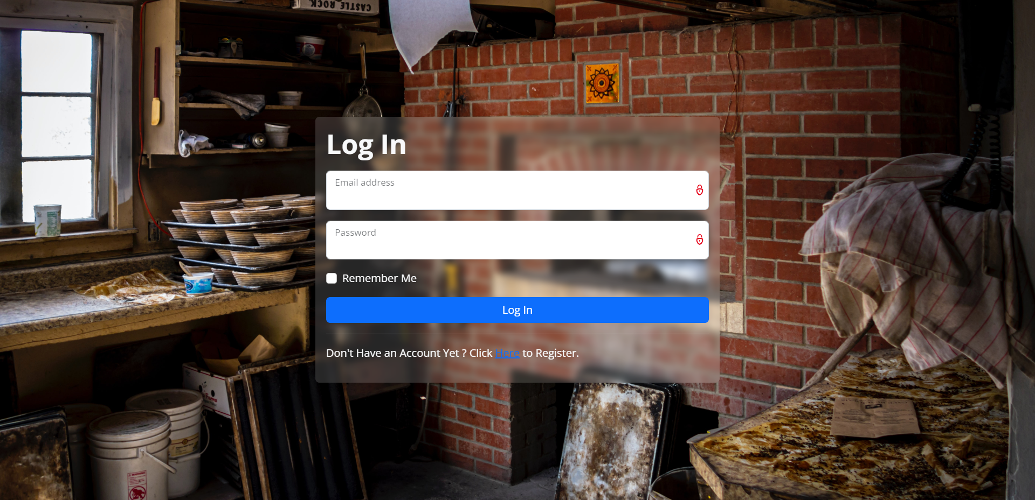

***Figure 1. Login Page***

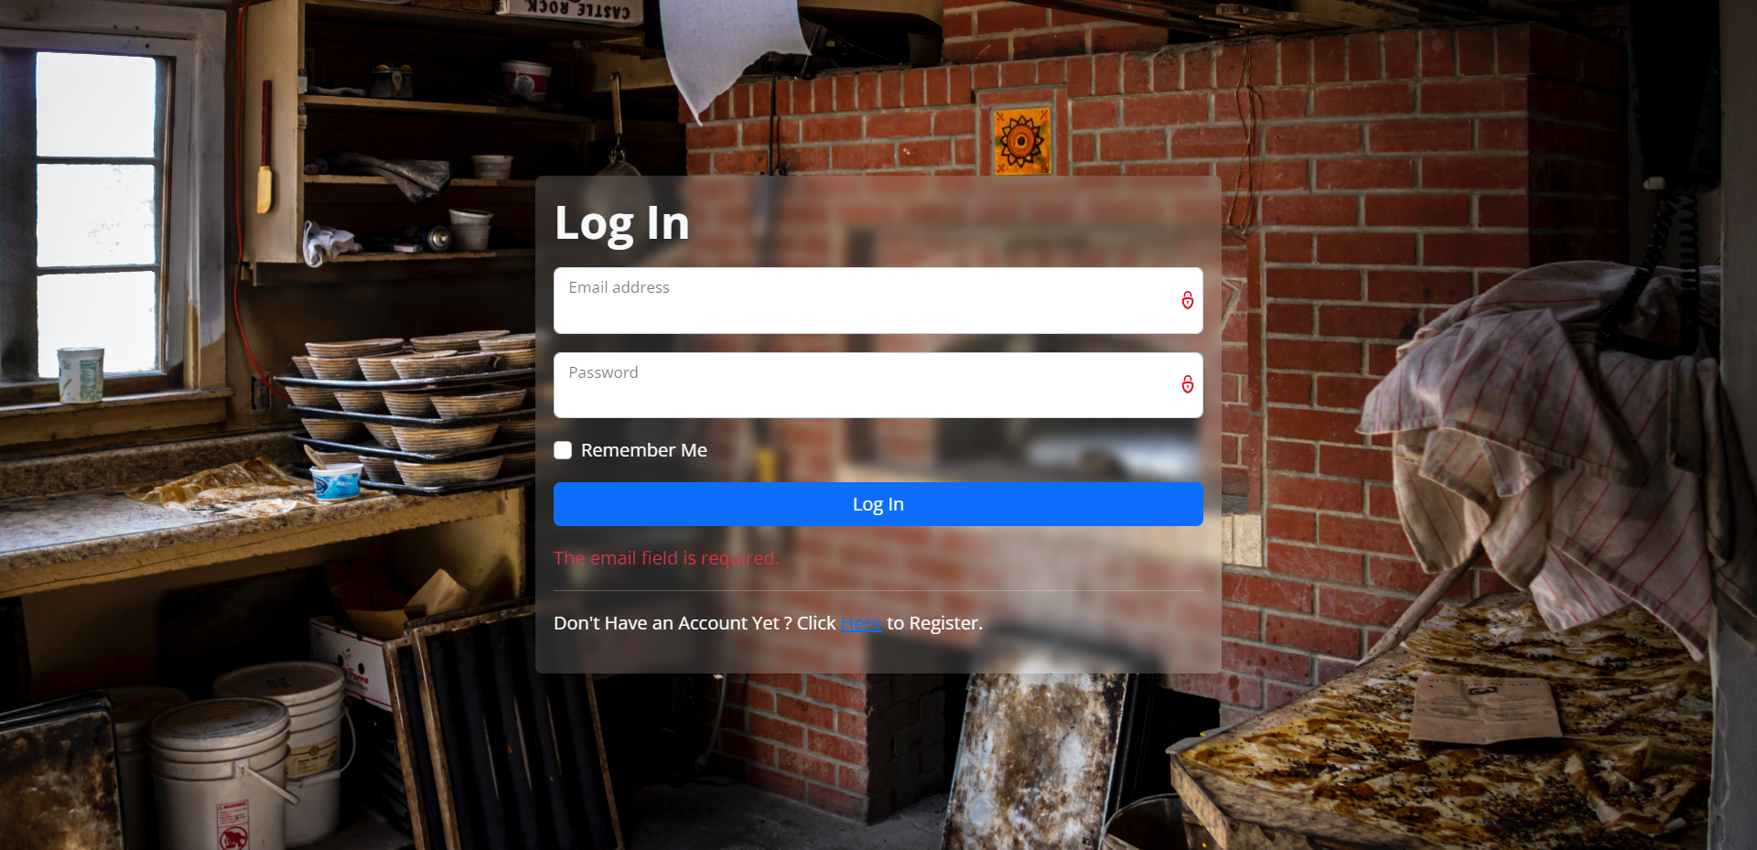

***Figure 2. Login Page (with an error message)***

1. **Register Page**

This page allows **guest** to **register** themselves as **Frawncis members**. If the user is **already logged in**, then **redirect** the user to the **Home Page**.

If the user **clicks on** the **Register button,** each field will be **validated** according to the table below. If the user inputs **incorrect data**, then the website will **show** an **error message**. Otherwise, **redirect** the user to the **Login Page** with a **success message**. If the user **clicks on** the **already have an account** **button**, **redirect** the user to the **Login Page**.

|  |  |
| --- | --- |
| Field | Rules |
| Full Name | Must be **filled** |
| Email | Must be **filled, in email format,** and **must be unique** |
| Password | Must be **filled,** **minimum length of 8 characters, and maximum length of 20 characters** |
| Confirm Password | Must be **filled** and **must be the same value as Password** |
| Terms | Must be **checked** |

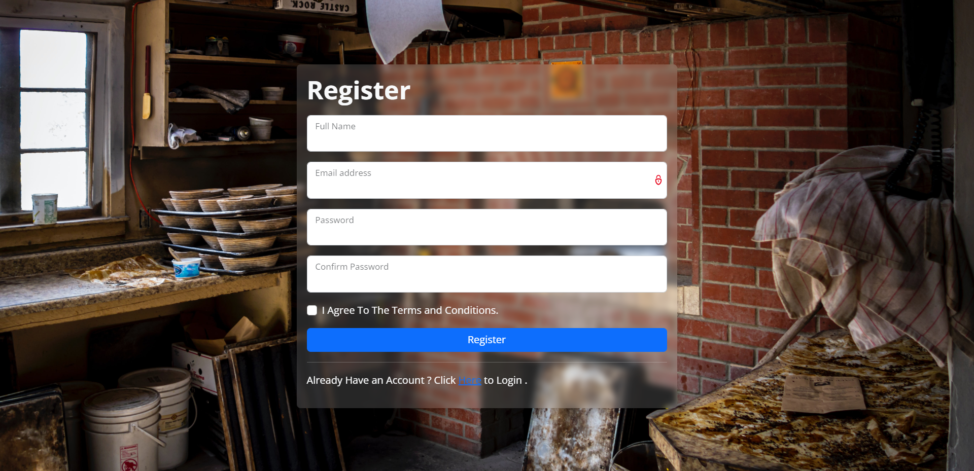

***Figure 3. Register Page***

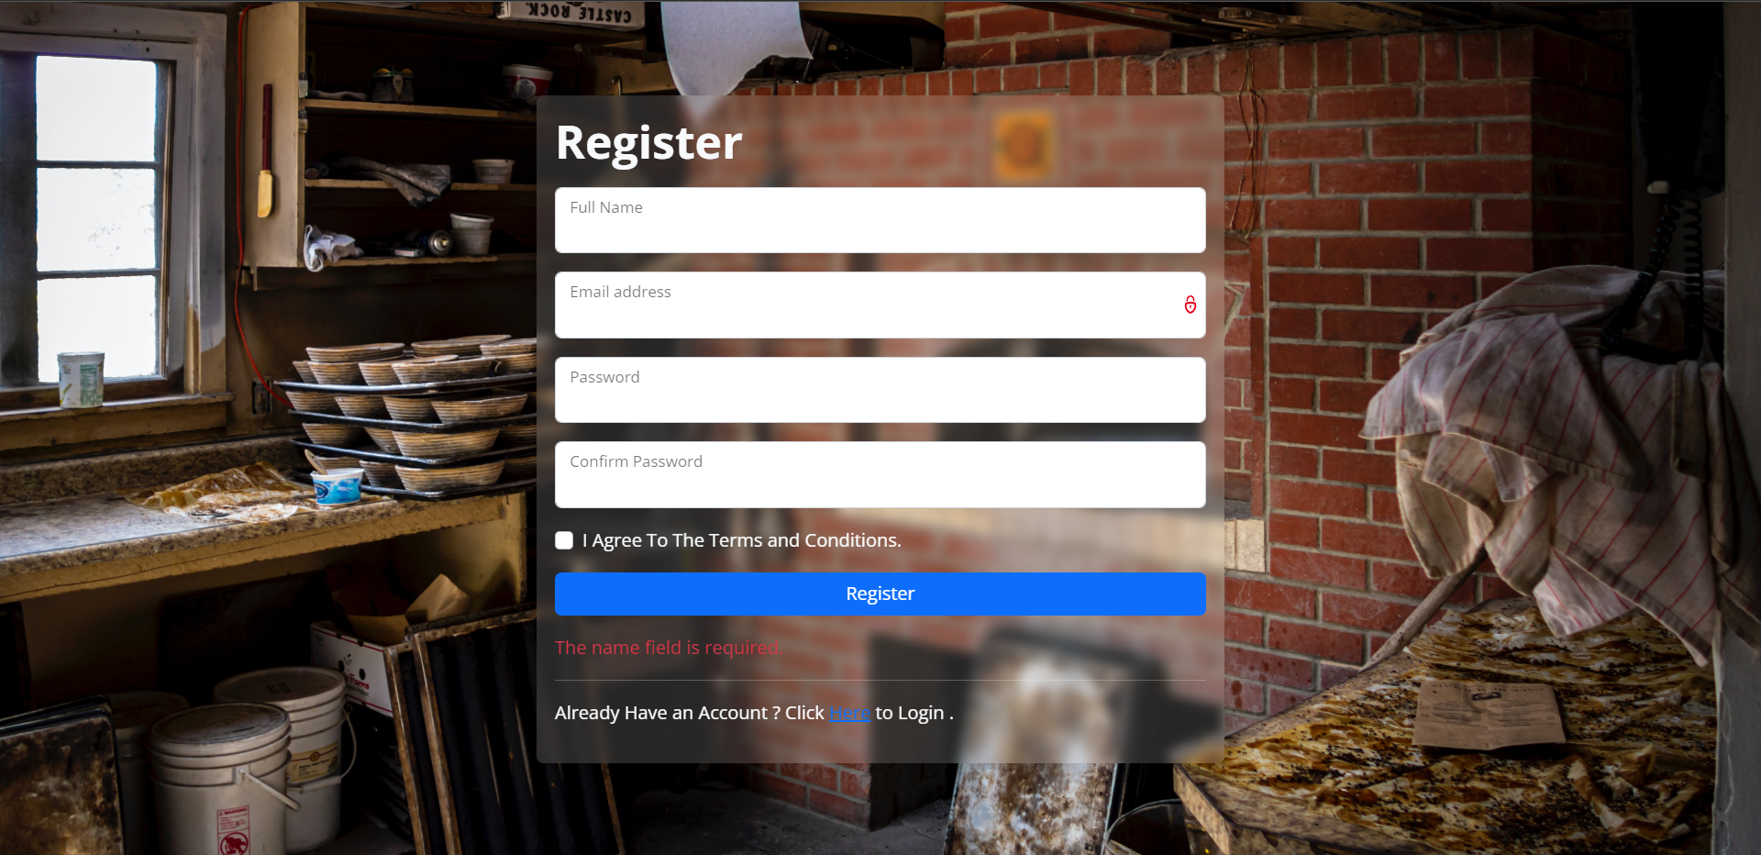

***Figure 4. Register Page (with an error message)***

1. **Home Page**

This page is the first page that a **member** or **admin** will see after they login and is **not accessible** by **guests**. The page will display the general information about the company. There are **home** button, **Our Locations** button, and **Our Products** button in the **navigation bar** that can be accessed by **all members**. Besides that, a **Manage Transaction** button will also appear for **all admins.** There is also a **search feature** to search games which will be **displayed** on the **Search Page**. If the user is a **Frawncis member**, display the **Profile dropdown button**, which contains several menus such as **Profile**, **Cart**, and **Log Out**. If the user is an **admin**, **display** the **Profile dropdown button**, **Log Out** menu.

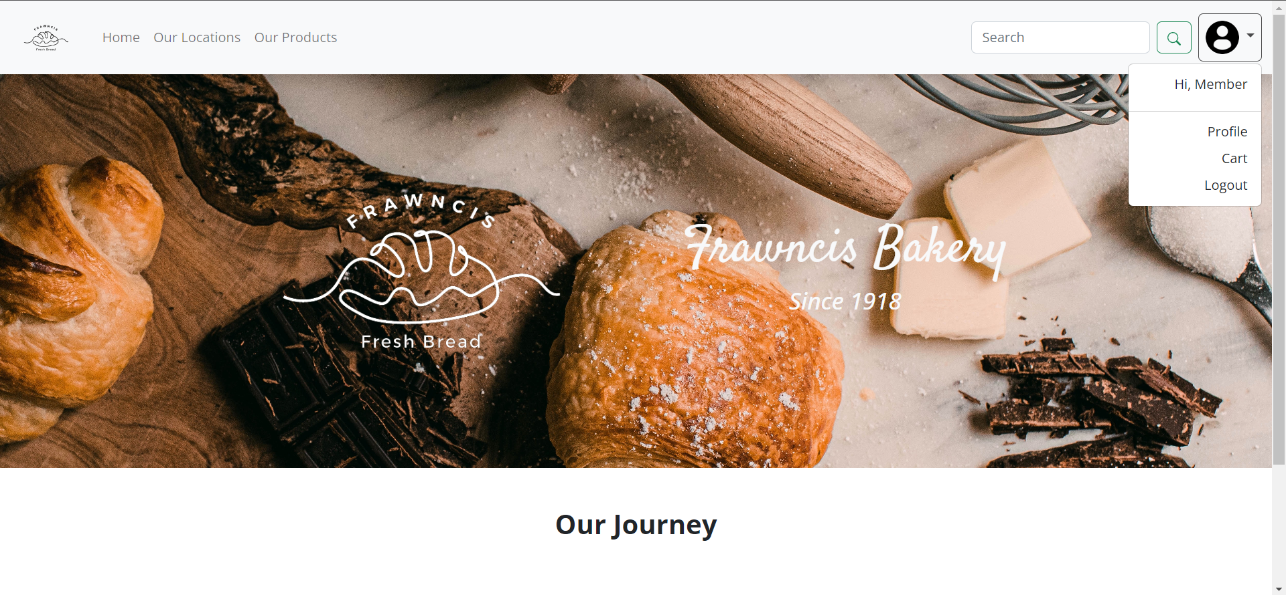

***Figure 5. Home Page (Member)***

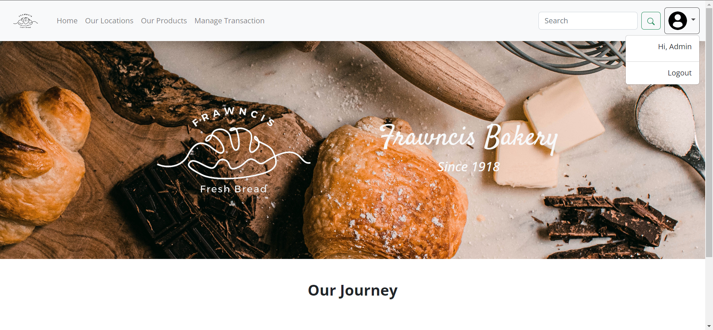

***Figure 6. Home Page (Admin)***

1. **Search Page**

This page contains the **search result** that the user did in the navigation bar and can be accessedby **members and admins.** The **members and admins** can search based on **Location** or **Product.** If the search resultis **not found** in the database, then **display** a **message** that the game was not found. Otherwise, display all the result(s) in the forms of **card** that is like the ones in **Product Page** and **Location Page**.

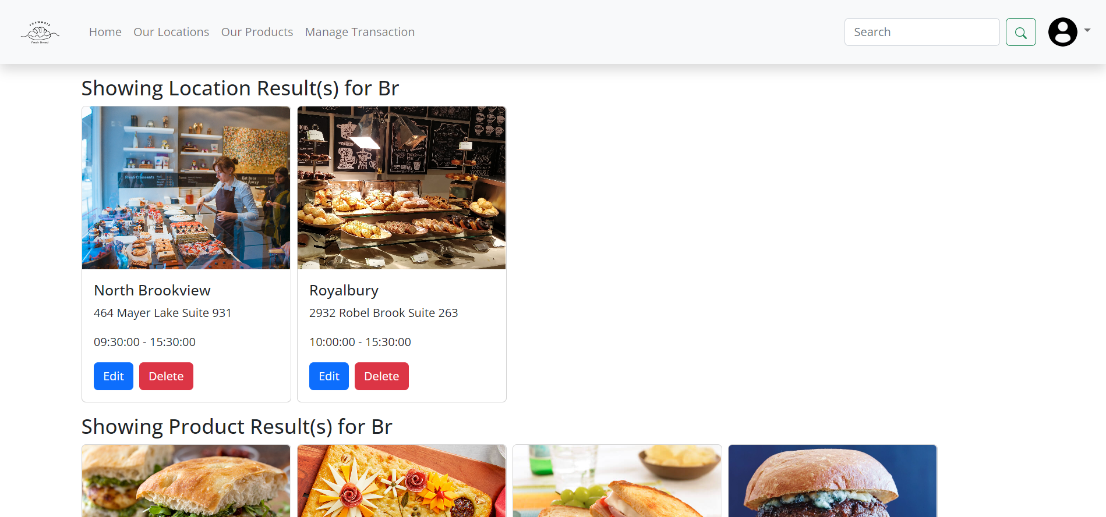

***Figure 7. Search Page (Admin)***

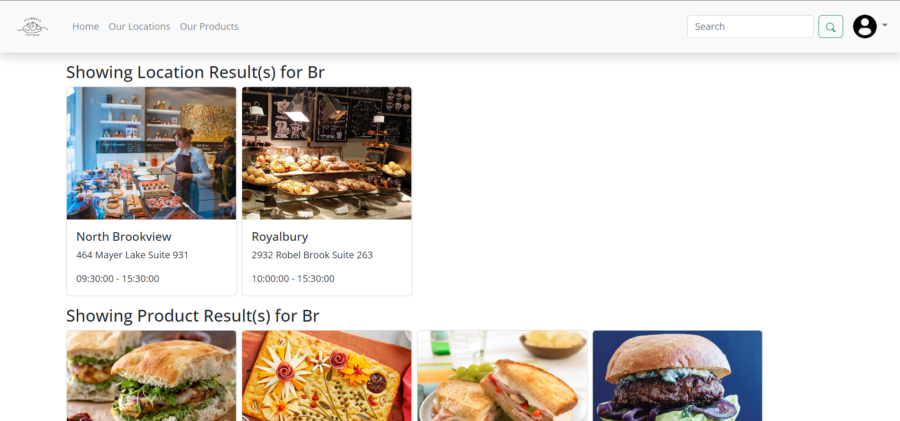

***Figure 8. Search Page (Member)***

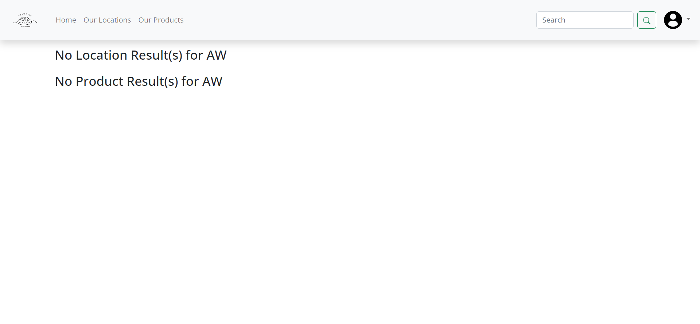

***Figure 9. Search Page (No Result Found)***

1. **Location Page**

This page contains all the locations of **Frawncis bakery** and is accessible for **all admins** and **members**.Each location’s details, such as the bakery’s image, city, address, and service hours will be displayed. For **admins,** there will also be additional buttons, such as the **Add Location** button, **Edit** button, and **Delete** button. The **Add Location** button will redirect the user to the **Add Location Page**. The **Edit** button will redirect the user to **Update Location Page**. The **Delete** button will **delete** **the selected location** from the database.

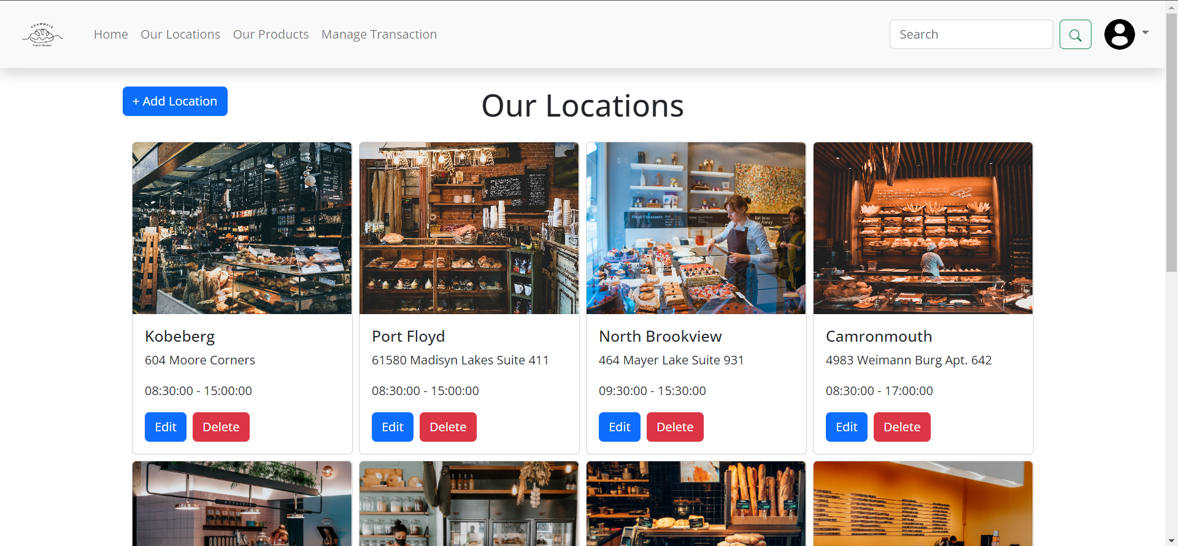

***Figure 10. Location Page (Admin)***

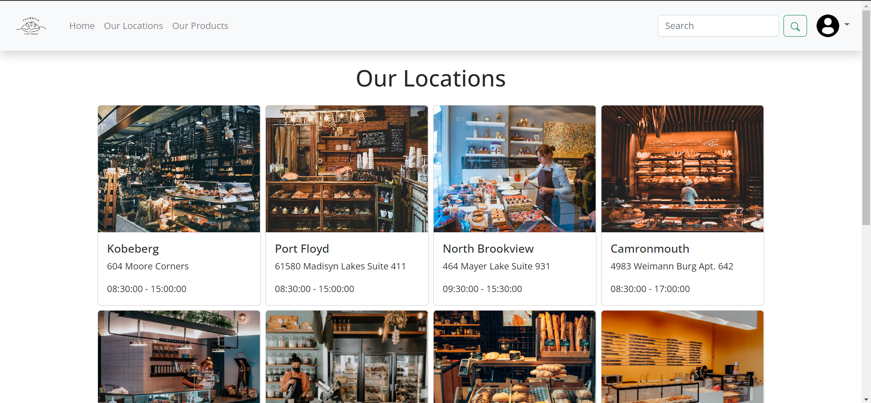

***Figure 10. Location Page (Member)***

1. **Product Page**

This page contains all the products of **Frawncis bakery** and is accessible for **all admins** and **members**. The products will be **sorted** with **the latest product** being displayed **first** and **paginated** with **8 products** on each page.Each product’s details, such as the product’s image, name, description, and price will be displayed. For **members**, there will be an **Add to Cart** button if the product has not been added to the user’s cart or a **Remove From Cart** button if the product has been added to the user’s cart. The **Add to Cart** button will add the selected product to the user’s cart when clicked. The **Remove from Cart** button will remove the selected item from the user’s cart. For **admins,** there will be three buttons, such as the **Add Product** button, **Edit** button, and **Delete** button. The **Add Product** button will redirect the user to the **Add Product Page**. The **Edit** button will redirect the user to **Update Product Page**. The **Delete** button will **delete** **the selected product** from the database.

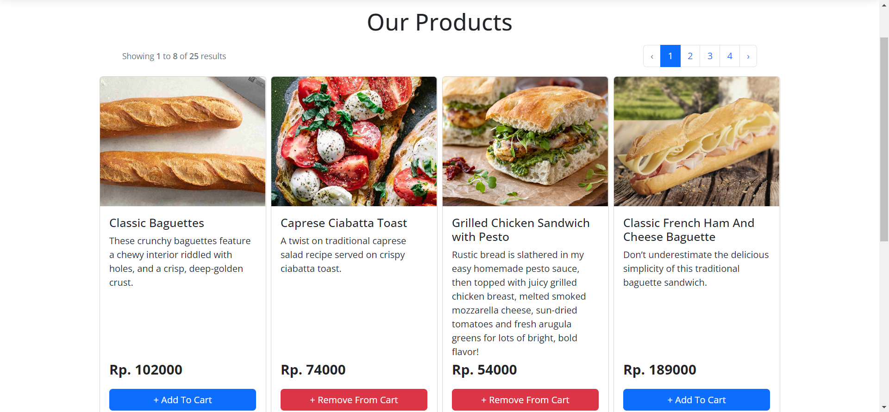

***Figure 11. Product Page (Member)***

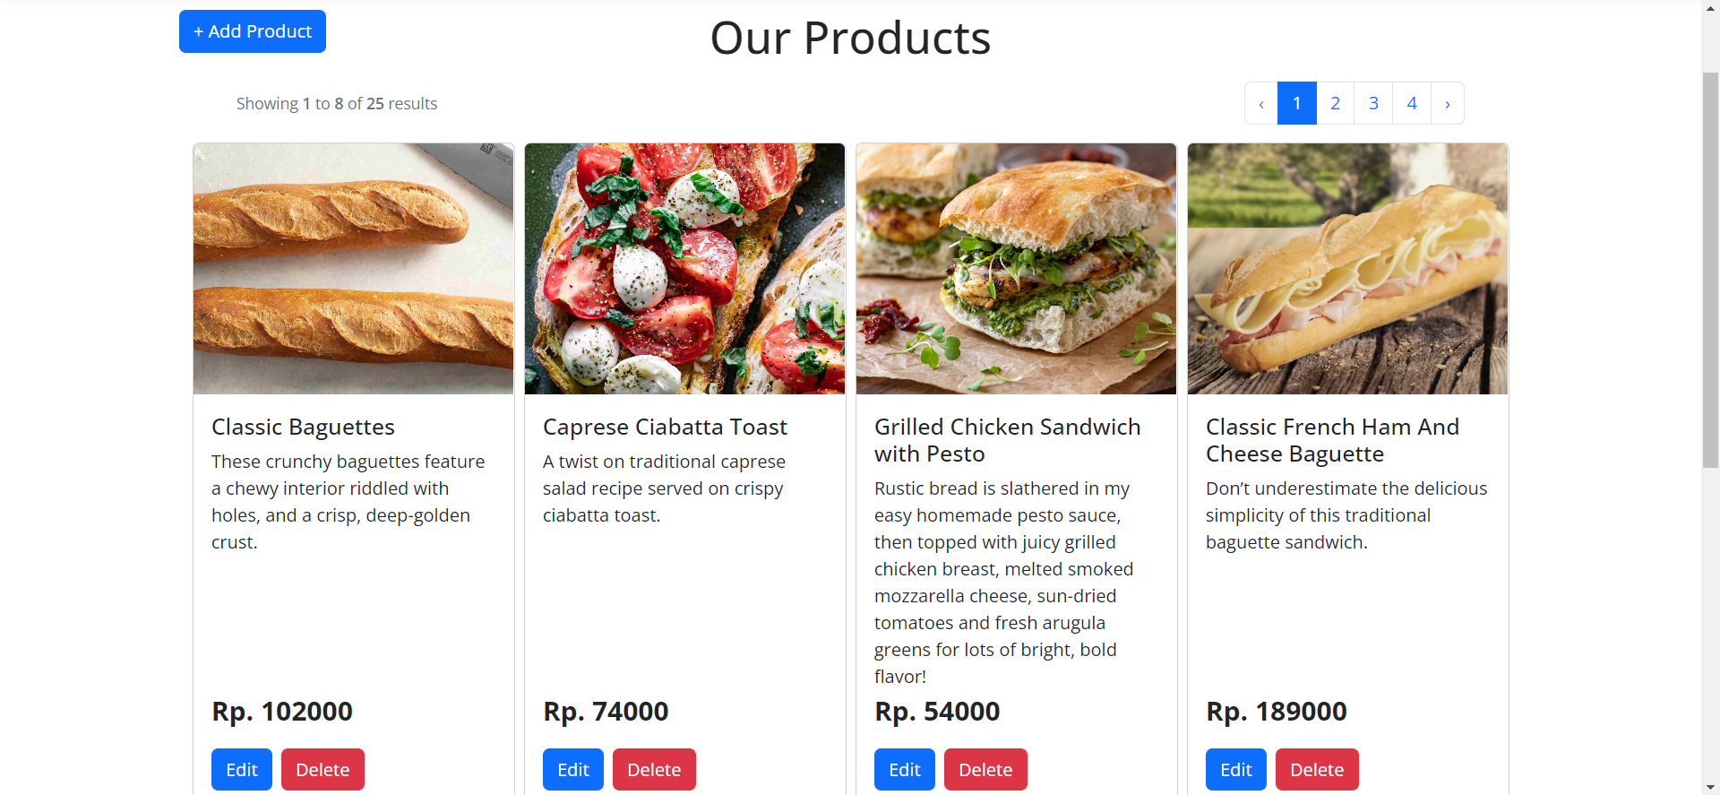

***Figure 12. Product Page (Admin)***

1. **Cart Page**

This page contains the **member’s cart** and is accessible only for **members**.All the products in the **member’s cart** will be displayed along with its quantity and price. There will be buttons to **increase the quantity** or **decrease the quantity** of each **product.** There will also be a **delete** button to remove the selected product from the **member’s cart.** The **member** can also **checkout** the cart after selecting the desired location from all **Frawncis’ locations** for pickup. Upon successful checkout, redirect the **member** to **Product Page** with success message, created using **Session.**

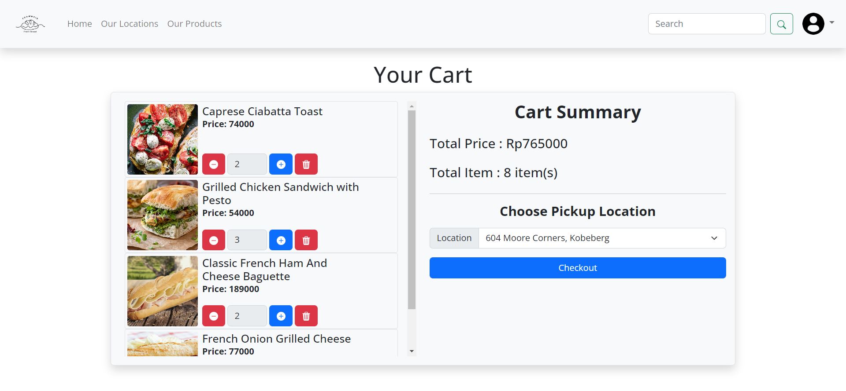

***Figure 13. Cart Page***

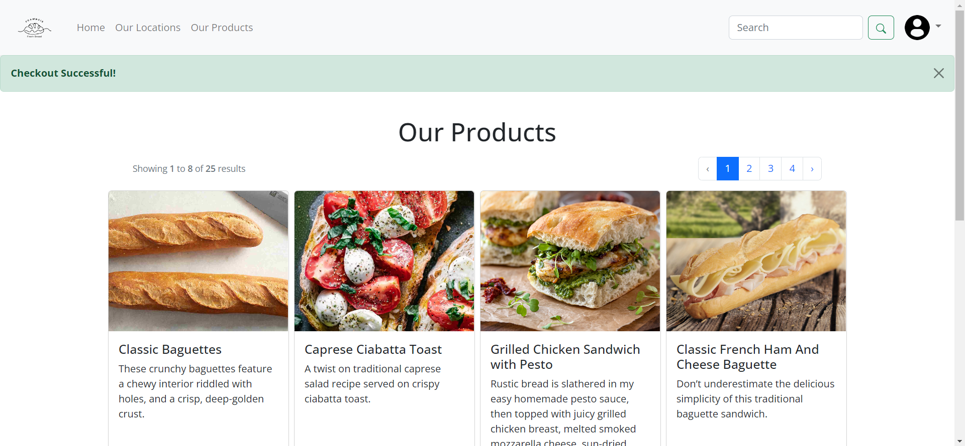

***Figure 14. Product Page (With Success Message)***

1. **Profile Page**

This page contains information of current user and is only accessible for **members**. There will be **two** main features in this page. The **first** is **updating the user’s basic information**, such as profile picture, name, and email. The following validations will be applied to the **first** feature. Error message will be displayed if there are any incorrect inputs. If there are no errors, change the user’s basic information on the database.

|  |  |
| --- | --- |
| Field | Rules |
| Name | Must be **filled** |
| Email | Must be **filled, in email format,** and **must be unique if the member decides to change email.** |
| Profile Picture | Must be **filled,** **maximum file size of 10MB, and must be in the format of either .jpg, .jpeg. or .png.** |

The **second** feature is **change password** feature. To change the **member’s** password, the following validations will be applied. Error message will be displayed if there are any incorrect inputs. If there are no errors, change the user’s password on the database. Then, display a success message, created using **Session**.

|  |  |
| --- | --- |
| Field | Rules |
| Current Password | Must be **filled, the same as the user’s current password** |
| New Password | Must be **filled, minimum 8 characters, and maximum 8 characters.** |
| Re-enter New Password | Must be **filled,** **must be the same value as New Password** |

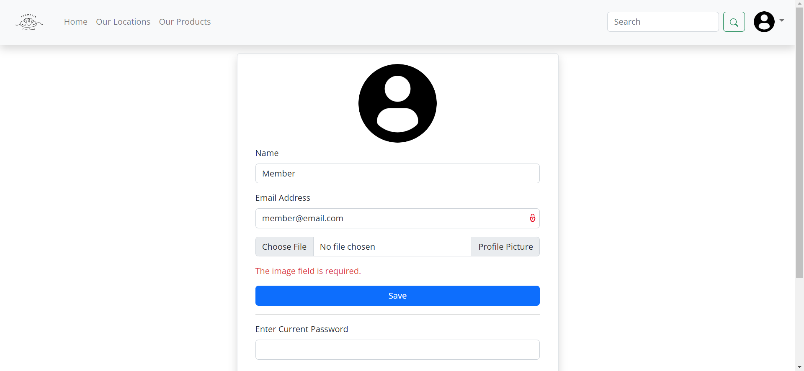

***Figure 15. Profile Page (First Feature with Error Message)***

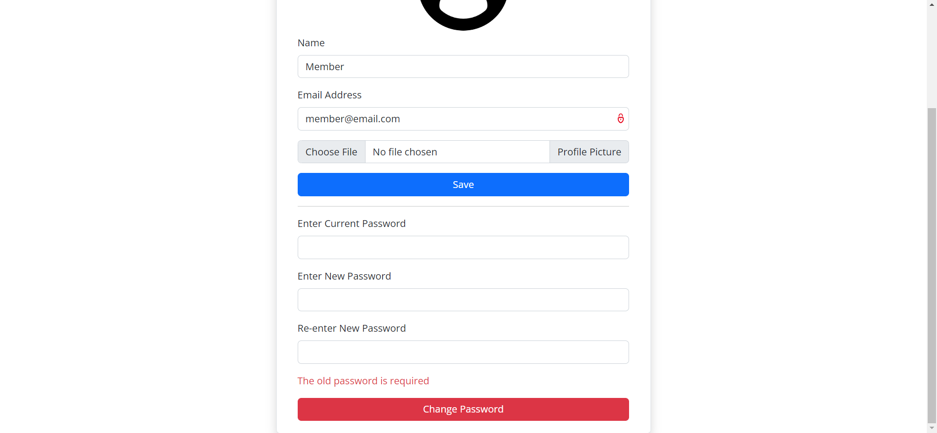

***Figure 16. Profile Page (Second Feature with Error Message)***

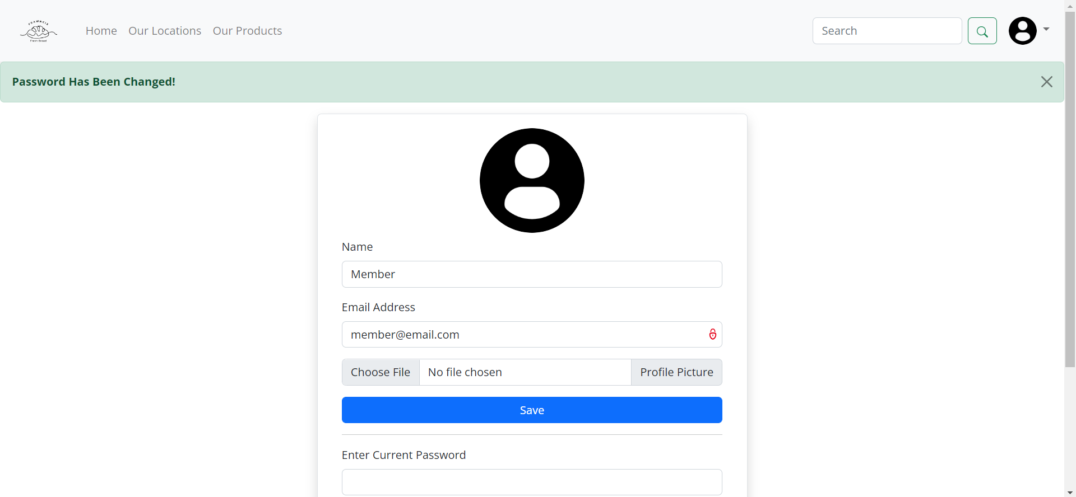

***Figure 17. Profile Page (with Success Message)***

1. **Add Location Page**

This page is only accessible for **admins** to **add a new location of Frawncis’ bakery**. The following forms will be displayed, and the following validations will be applied to each field. Error message will be displayed if there are any incorrect inputs. If there are no errors, add the new location to the database. Then, redirect the user to Location page with success message, created using **Session**.

|  |  |
| --- | --- |
| Field | Rules |
| City | Must be **filled** and **max. 30 characters** |
| Address | Must be **filled** and **max. 50 characters** |
| Opening Hours | Must be **filled** |
| Closing Hours | Must be **filled** and **after Opening Hours** |
| Image | Must be **filled,** **maximum file size of 10MB, and must be in the format of either .jpg, .jpeg. or .png.** |

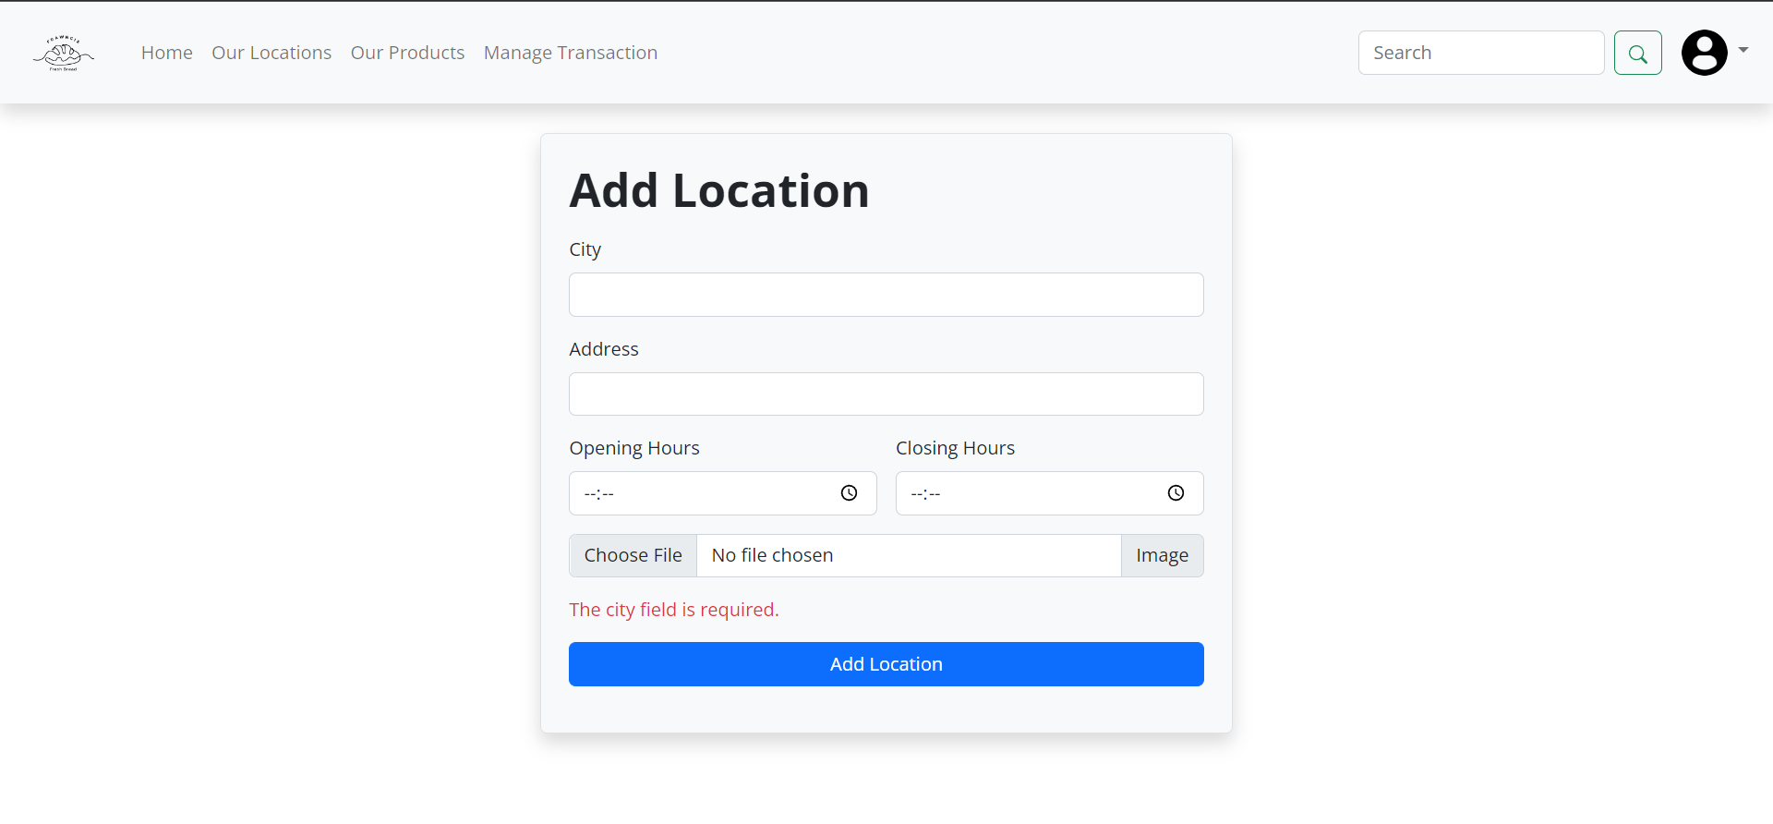

***Figure 18. Add Location Page (with Error Message)***

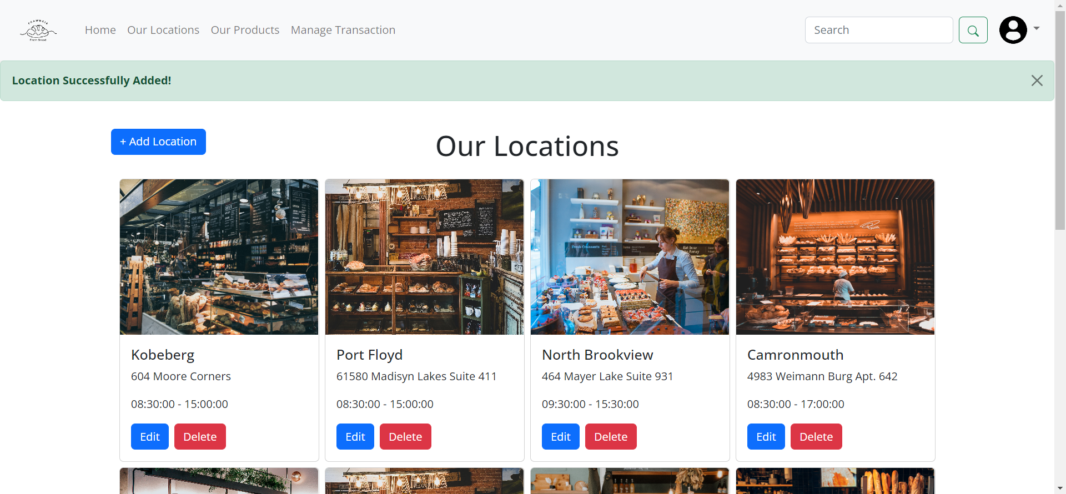

***Figure 19. Location Page (with Success Message)***

1. **Update Location Page**

This page is only accessible for **admins** to **update the detail of a location of Frawncis’ bakery**. The following forms will be displayed, and the following validations will be applied to each field. Error message will be displayed if there are any incorrect inputs. If there are no errors, update the new location’s details to the database. Then, redirect the user to Location page with success message, created using **Session**.

|  |  |
| --- | --- |
| Field | Rules |
| City | Must be **filled** and **max. 30 characters** |
| Address | Must be **filled** and **max. 50 characters** |
| Opening Hours | Must be **filled** |
| Closing Hours | Must be **filled** and **after Opening Hours** |
| Image | Must be **filled,** **maximum file size of 10MB, and must be in the format of either .jpg, .jpeg. or .png.** |

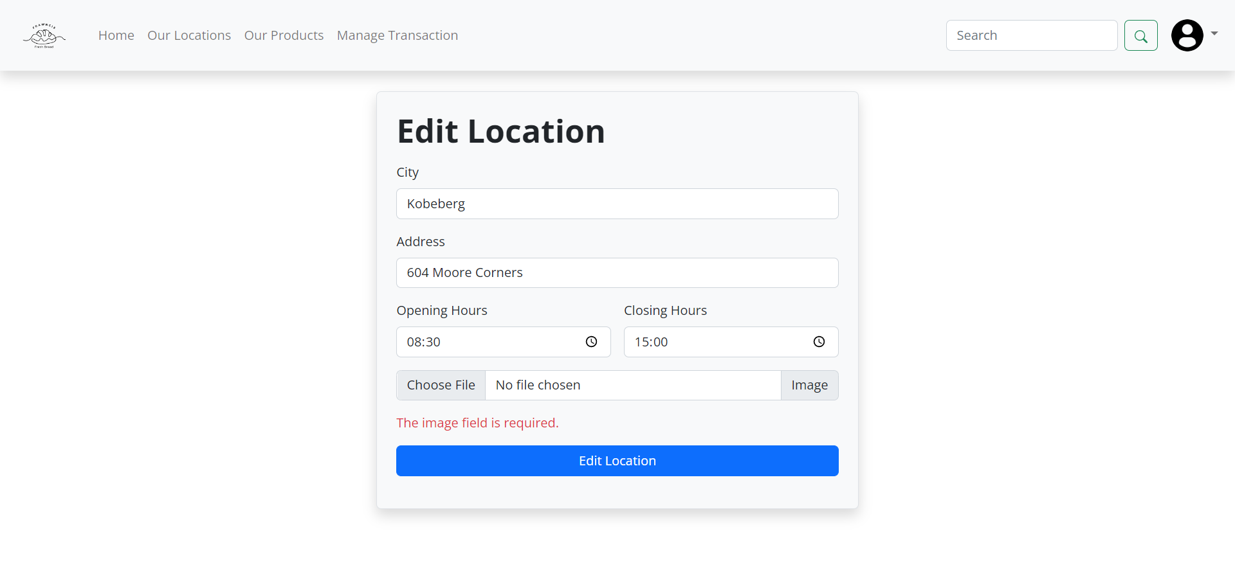

***Figure 20. Update Location Page (with Error Message)***

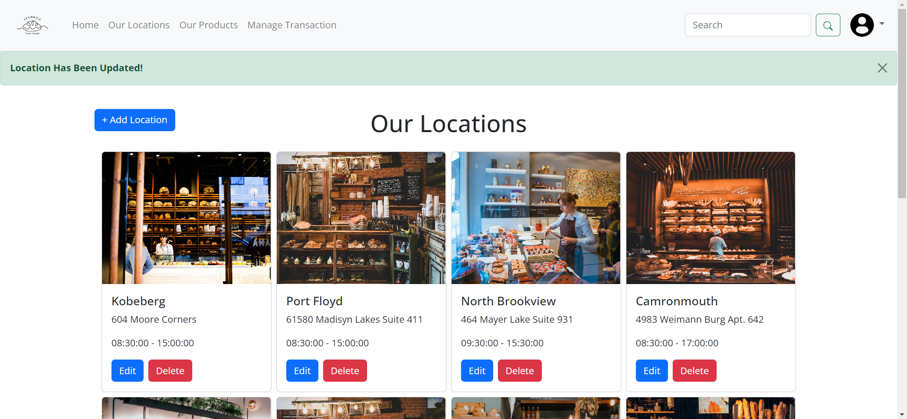

***Figure 21. Location Page (with Success Message)***

1. **Add Product Page**

This page is only accessible for **admins** to **add a new product of Frawncis’ bakery**. The following forms will be displayed, and the following validations will be applied to each field. Error message will be displayed if there are any incorrect inputs. If there are no errors, add the new location to the database. Then, redirect the user to Product page with success message, created using **Session**.

|  |  |
| --- | --- |
| Field | Rules |
| Name | Must be **filled** and **max. 50 characters** |
| Price | Must be **filled,** must be **integer** and **with minimum value of 1000** |
| Description | Must be **filled** |
| Product Types | Must be **filled** and **exists in the product types table.** |
| Image | Must be **filled,** **maximum file size of 10MB, and must be in the format of either .jpg, .jpeg. or .png.** |

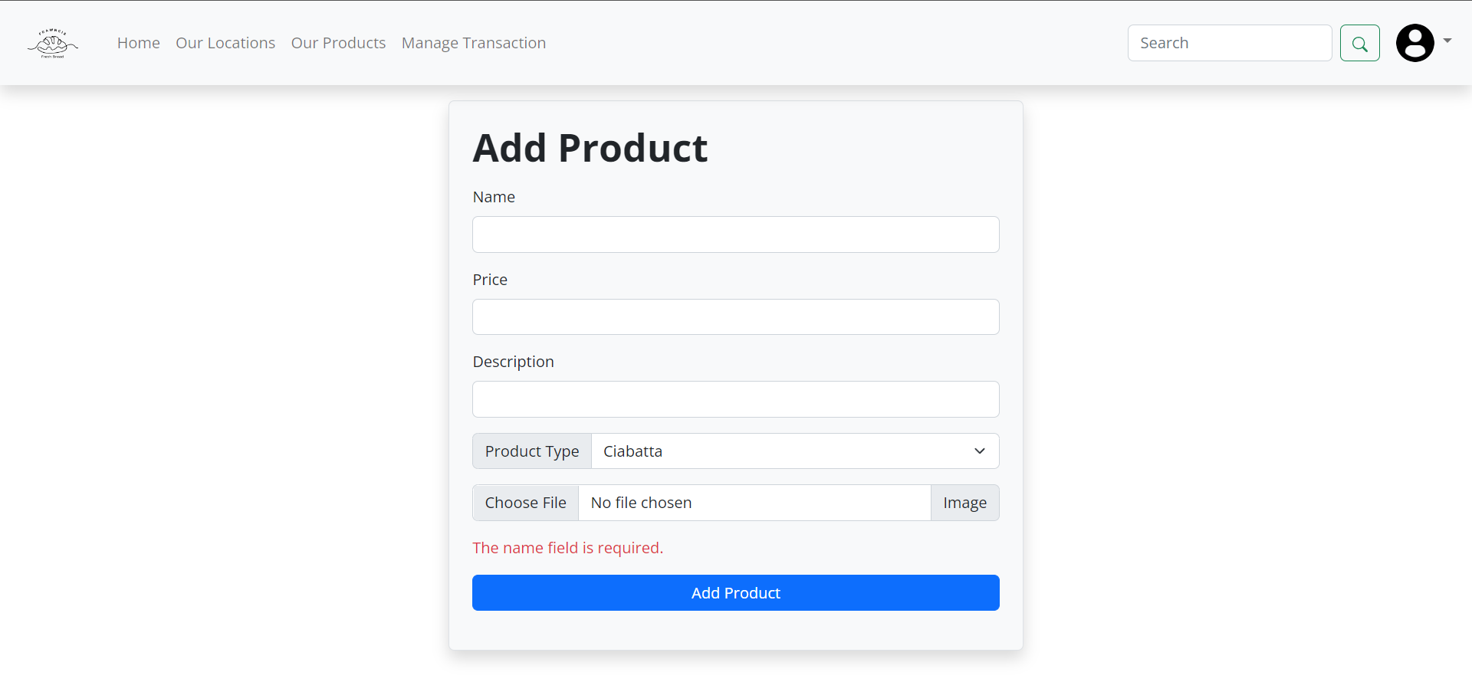

***Figure 22. Add Product Page (with Error Message)***

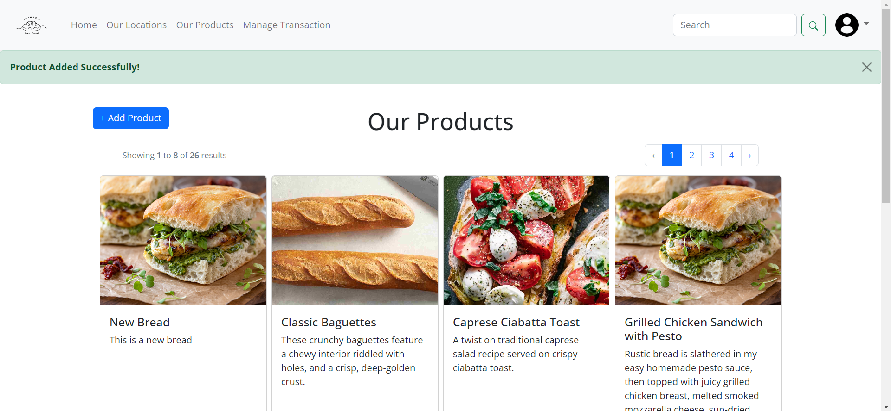

***Figure 23. Product Page (with Success Message)***

1. **Update Product Page**

This page is only accessible for **admins** to **update the selected product of Frawncis’ bakery**. The following forms will be displayed, and the following validations will be applied to each field. Error message will be displayed if there are any incorrect inputs. If there are no errors, add the new location to the database. Then, redirect the user to Product page with success message, created using **Session**.

|  |  |
| --- | --- |
| Field | Rules |
| Name | Must be **filled** and **max. 50 characters** |
| Price | Must be **filled,** must be **integer** and **with minimum value of 1000** |
| Description | Must be **filled** |
| Product Types | Must be **filled** and **exists in the product types table.** |
| Image | Must be **filled,** **maximum file size of 10MB, and must be in the format of either .jpg, .jpeg. or .png.** |

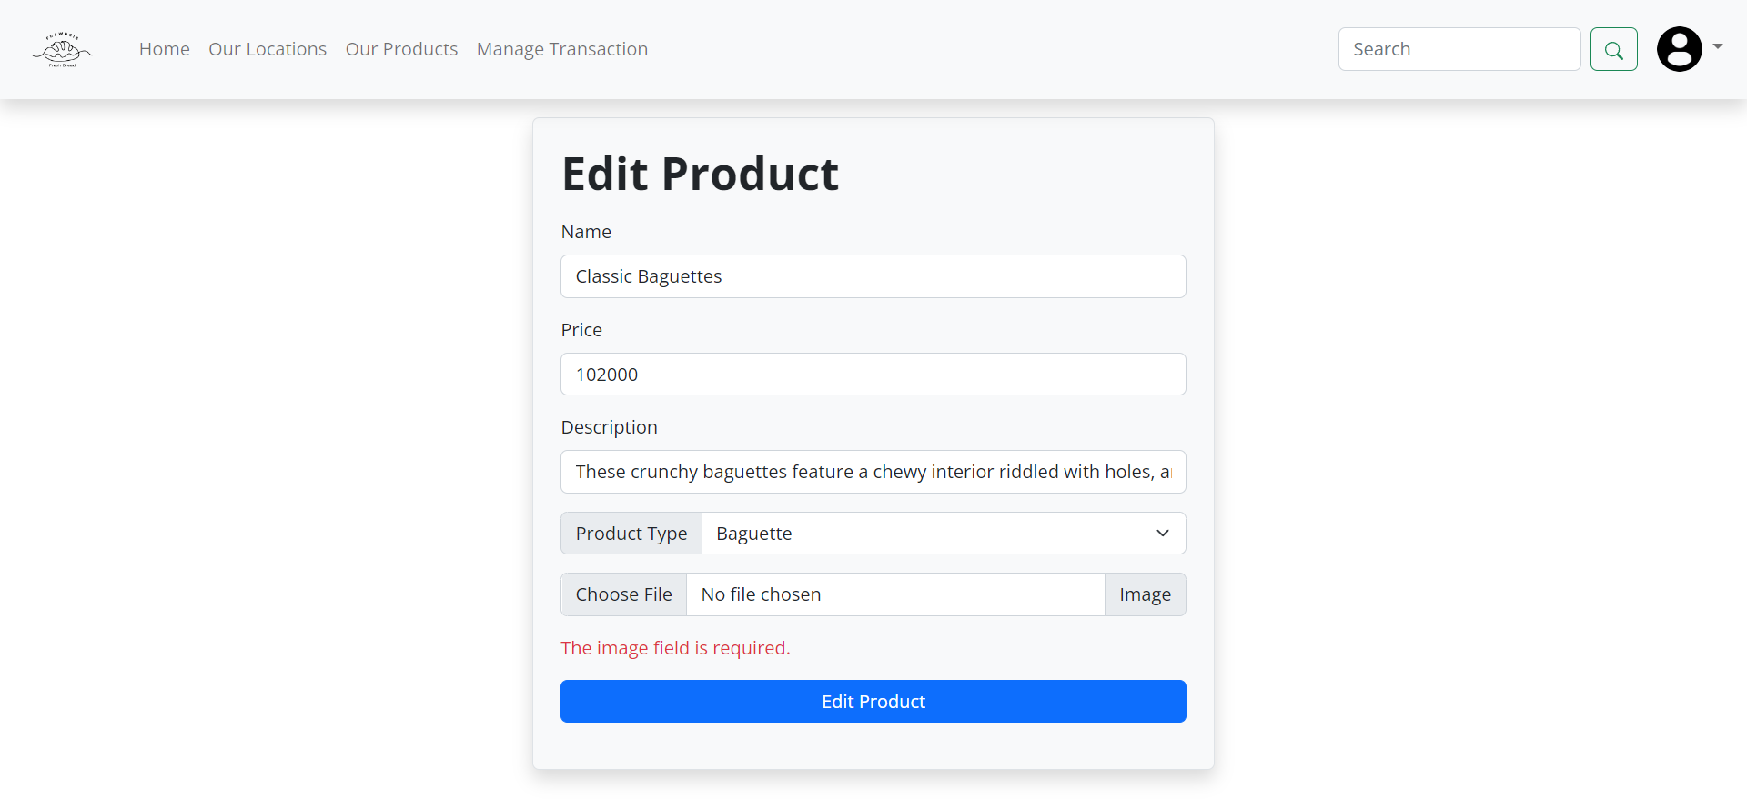

***Figure 24. Update Product Page (with Error Message)***

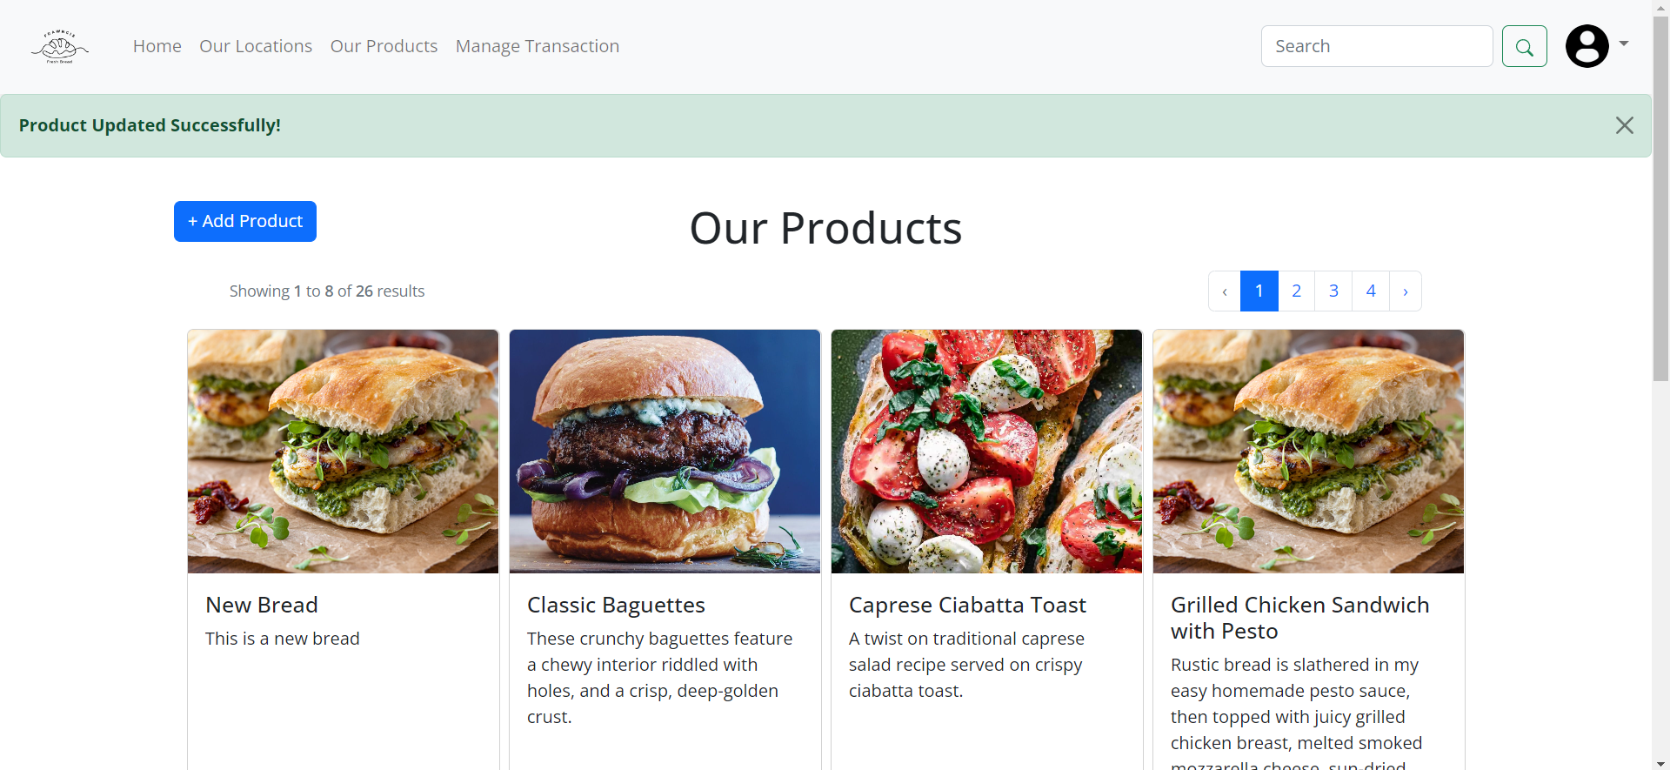

***Figure 25. Product Page (with Success Message)***

1. **Transaction Page**

This page is only accessible for **admins** to **view all transactions** and **manage pickup status** of each transaction. This page will display each transaction’s details, such as the user’s name, the city of the pickup location, transaction date, product name, price, quantity, and subtotal. For each transaction, the total price and pickup status will also be displayed. There is also a **Picked-Up** button, which will change the pickup status to picked up if it is clicked.

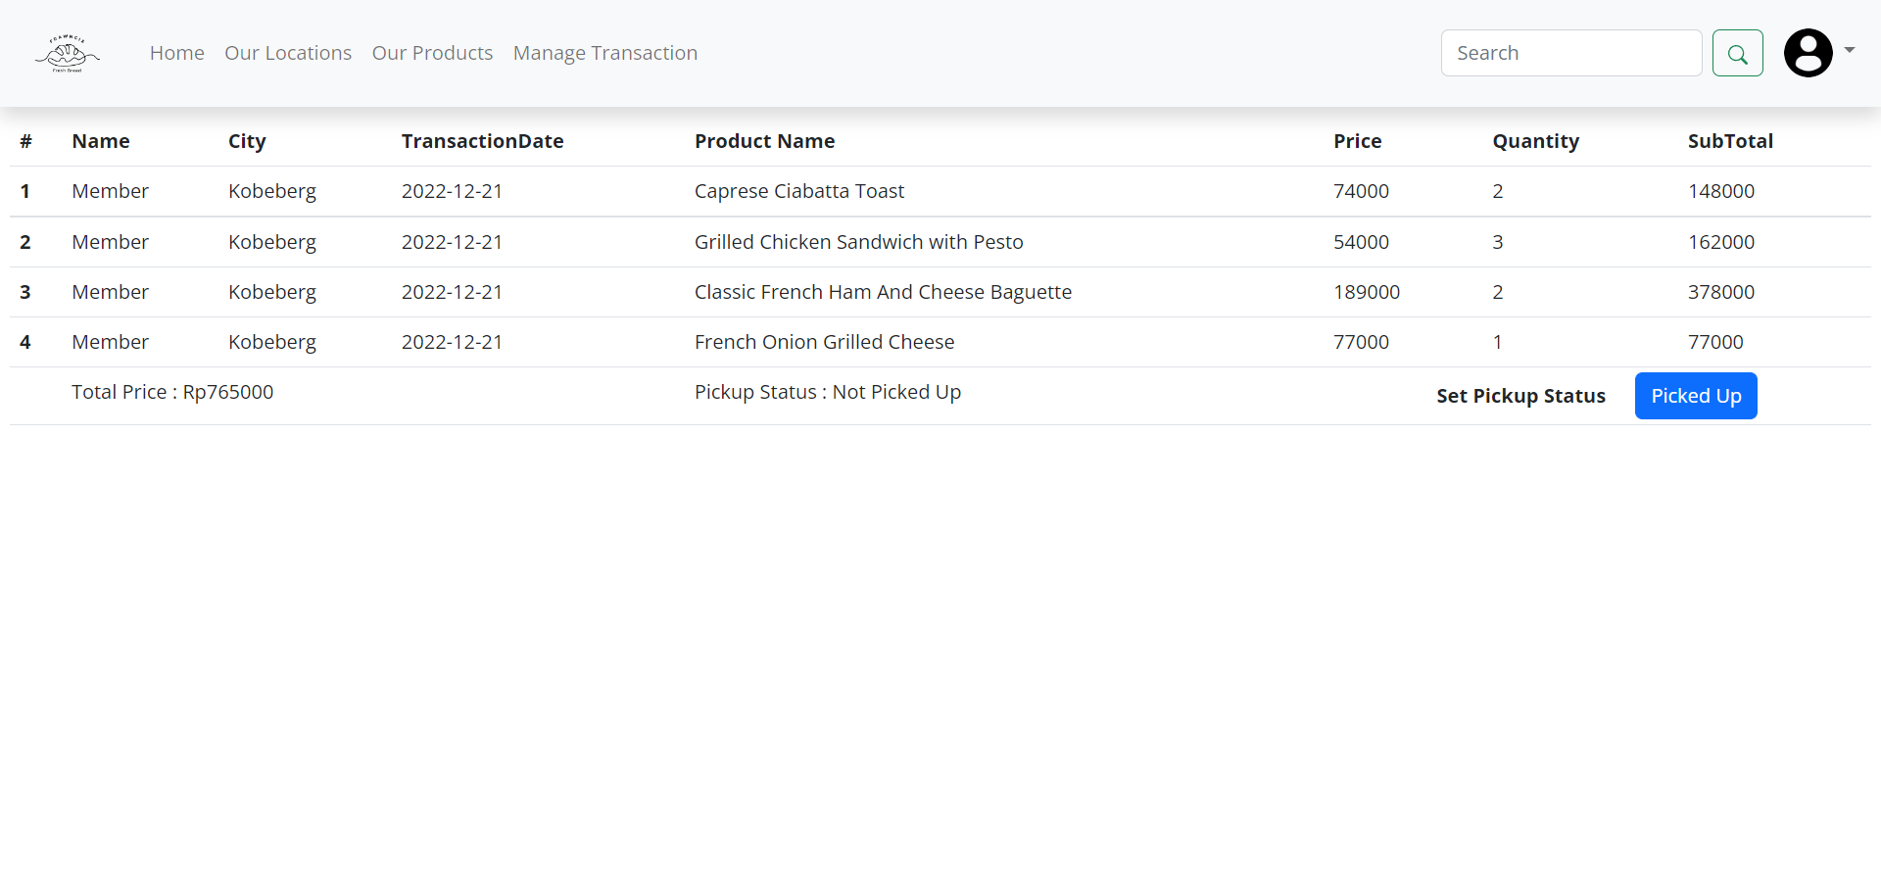

***Figure 26. Manage Transaction Page***